NAME : R.ANGALA PARAMESWARI
DATASET : DIABETES
DATE : 06.12.25
BATCH : DADS-AUGUST
S.NO | TOPICS
1. | Data Cleaning and Preparation
2. | Data Import into MySQL
3. | SQL Queries
4. | Data Export and Table Setup in Excel
5. | Pivot Tables and Pivot Charts
6. | Dashboard Creation
7. | Documentation
8. | PPT & Presentation

Display records:
SELECT * FROM diabetes.`diabetes dataset _csv`;
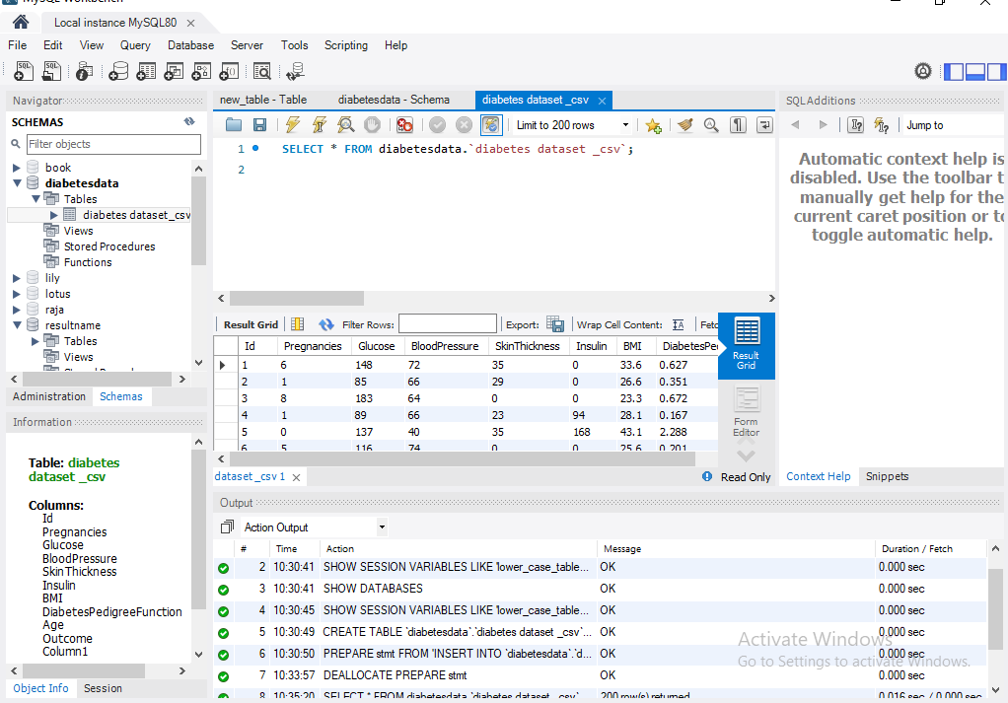

Total records:
SELECT COUNT(*) AS total_records
FROM diabetes.`diabetes dataset _csv`;
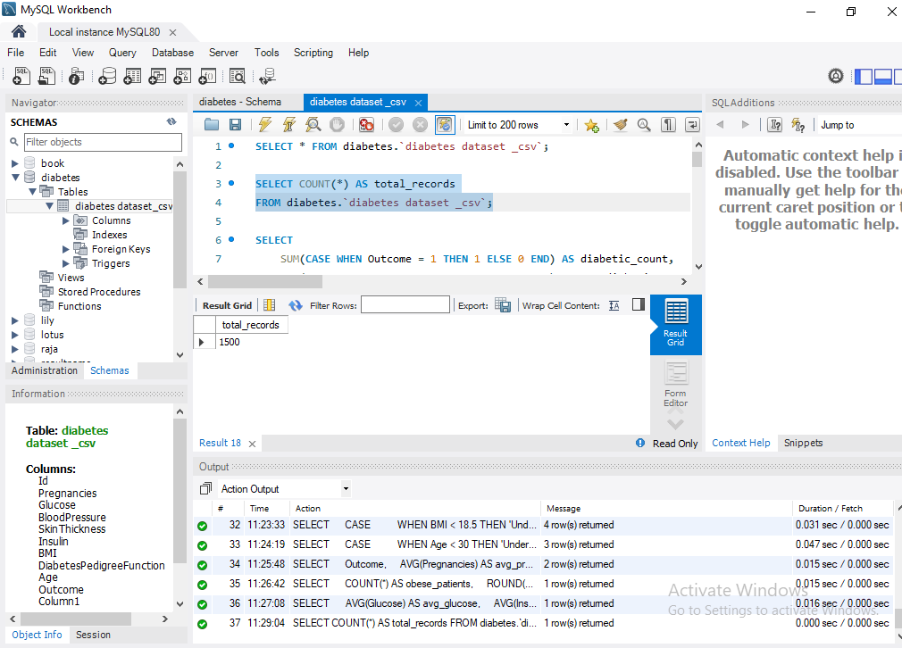

Diabetes Prevalence (Outcome = 1):
SELECT
SUM(CASE WHEN Outcome = 1 THEN 1 ELSE 0 END) AS diabetic_count,
SUM(CASE WHEN Outcome = 0 THEN 1 ELSE 0 END) AS non_diabetic_count,
ROUND(AVG(Outcome) * 100, 2) AS diabetes_prevalence_percent
FROM diabetes.`diabetes dataset _csv`;
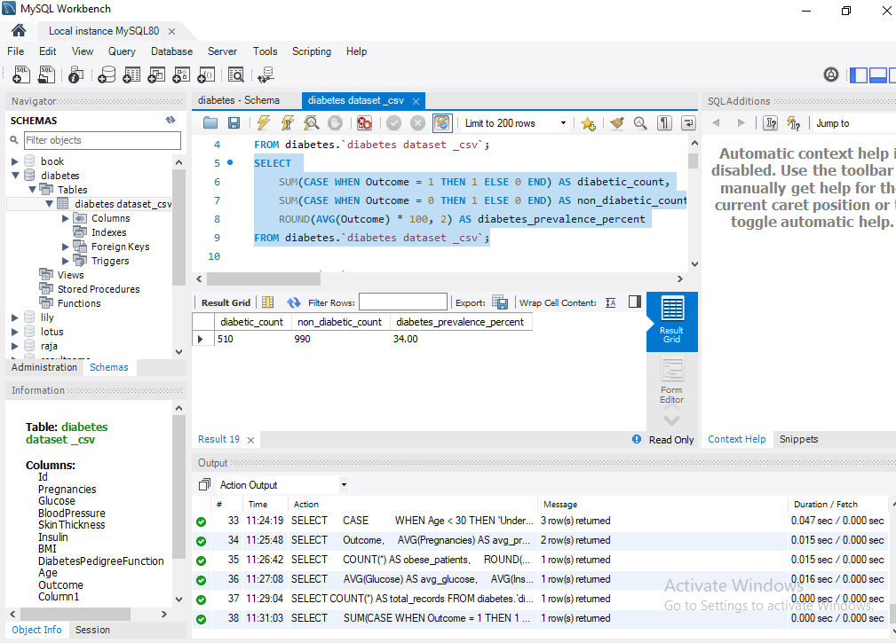

Average Age of Patients:

SELECT AVG(Age) AS avg_age

FROM diabetes.`diabetes dataset _csv`;
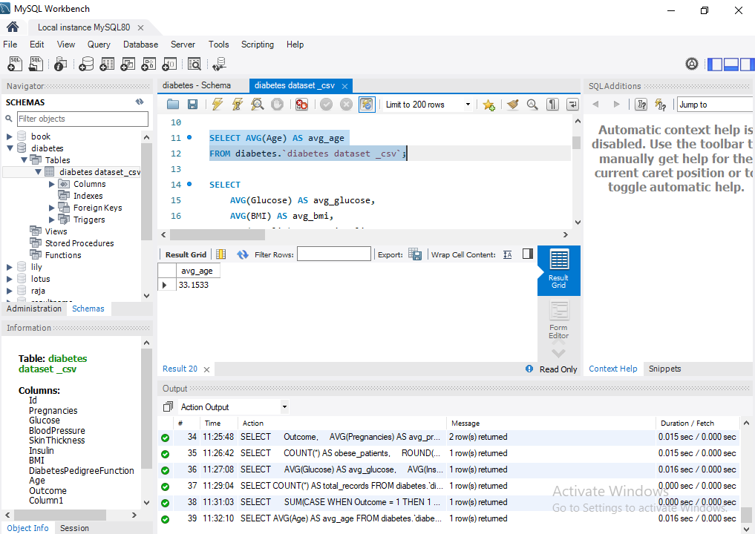
Average Glucose, BMI, Insulin Levels:
SELECT
AVG(Glucose) AS avg_glucose,
AVG(BMI) AS avg_bmi,
AVG(Insulin) AS avg_insulin
FROM diabetes.`diabetes dataset _csv`;
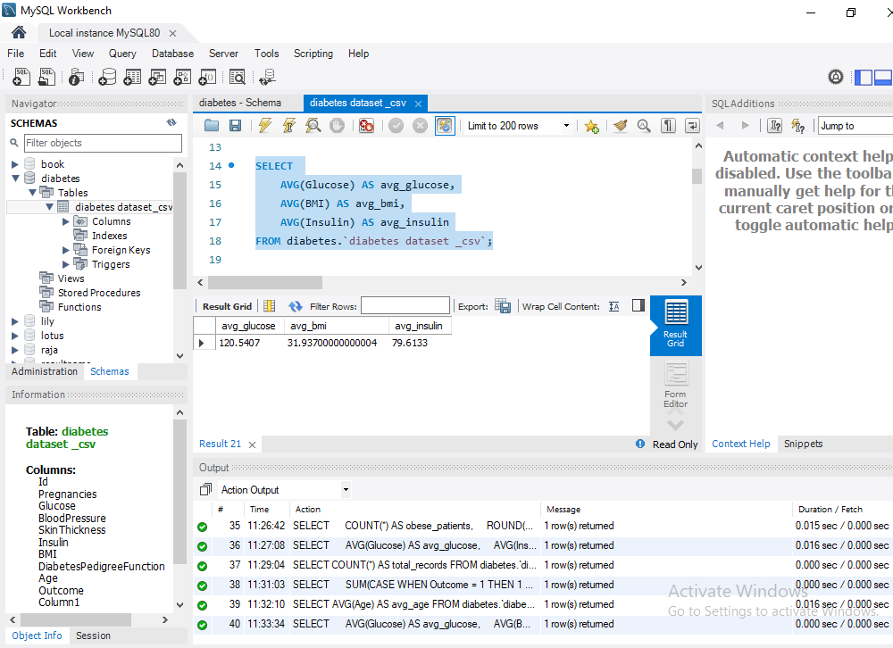
KPIs Grouped by Diabetes Outcome:
SELECT
Outcome,
COUNT(*) AS total,
AVG(Glucose) AS avg_glucose,
AVG(BMI) AS avg_bmi,
AVG(Age) AS avg_age,
AVG(Pregnancies) AS avg_pregnancies
FROM diabetes.`diabetes dataset _csv`
GROUP BY Outcome;
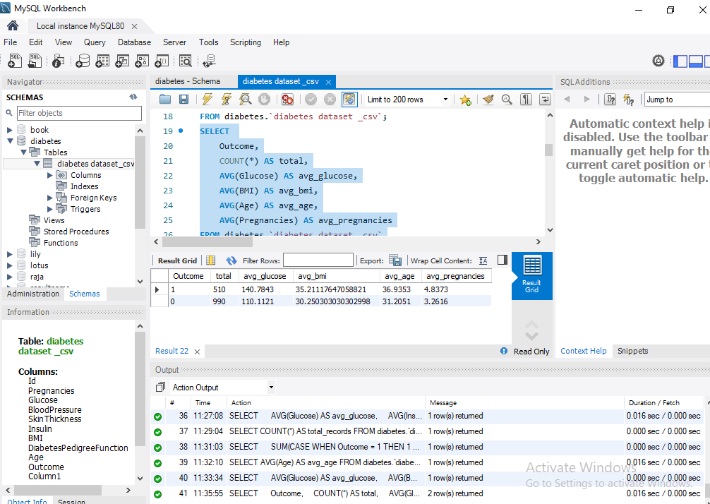

Risk KPI: High-Glucose Patients (Glucose > 140):
SELECT
COUNT(*) AS high_glucose_count,
ROUND(COUNT(*) * 100.0 / (SELECT COUNT(*) FROM diabetes.`diabetes dataset _csv`), 2) AS high_glucose_percent
FROM diabetes.`diabetes dataset _csv`
WHERE Glucose > 140;
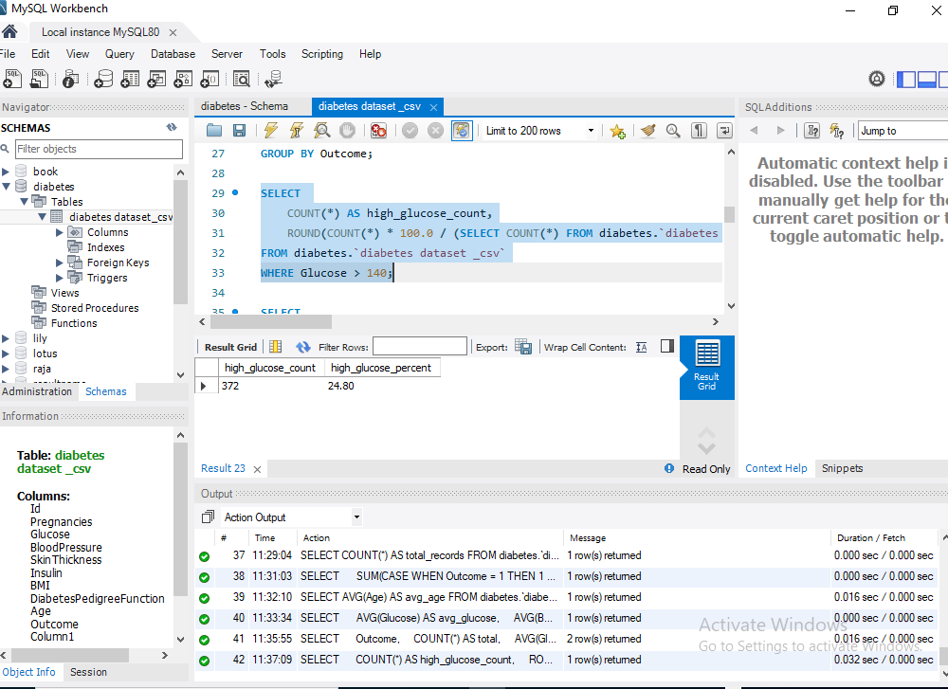
BMI Categories KPI:
SELECT
CASE
WHEN BMI < 18.5 THEN 'Underweight'
WHEN BMI BETWEEN 18.5 AND 24.9 THEN 'Normal'
WHEN BMI BETWEEN 25 AND 29.9 THEN 'Overweight'
ELSE 'Obese'
END AS bmi_category,
COUNT(*) AS total
FROM diabetes.`diabetes dataset _csv`
GROUP BY bmi_category;
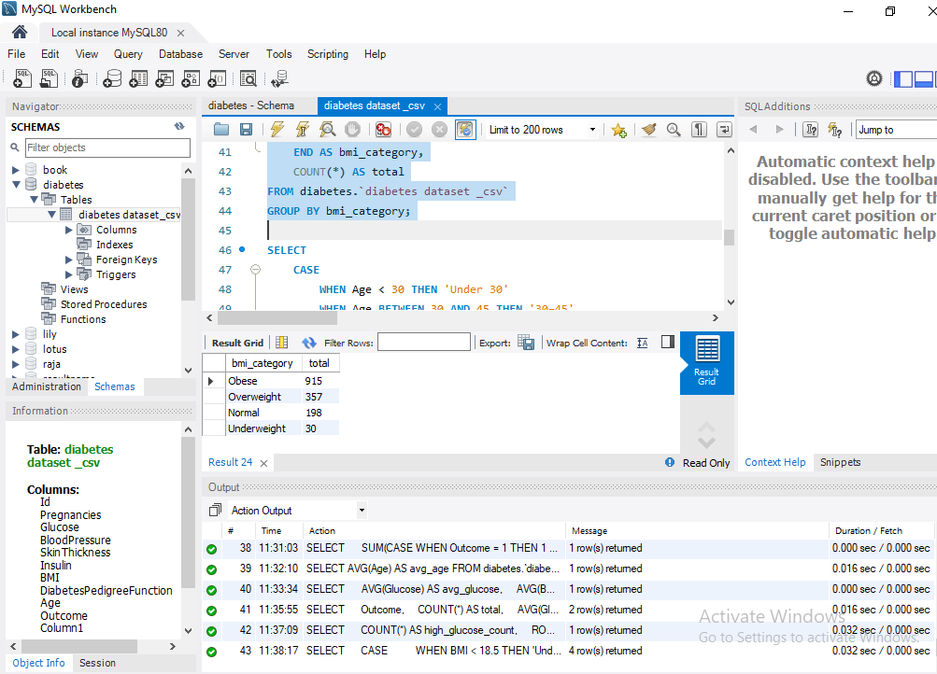
Age Group Distribution:
SELECT
CASE
WHEN Age < 30 THEN 'Under 30'
WHEN Age BETWEEN 30 AND 45 THEN '30–45'
ELSE '45+'
END AS age_group,
COUNT(*) AS total
FROM diabetes.`diabetes dataset _csv`
GROUP BY age_group;
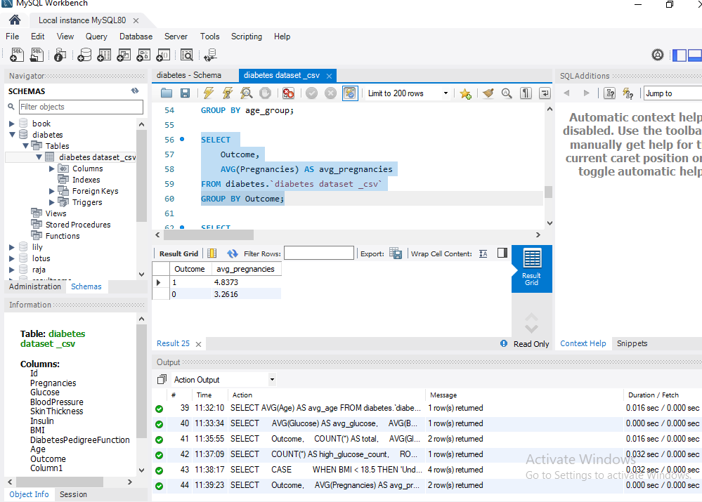

Average Pregnancies by Diabetes Outcome:

SELECT

Outcome,

AVG(Pregnancies) AS avg_pregnancies

FROM diabetes.`diabetes dataset _csv`

GROUP BY Outcome;
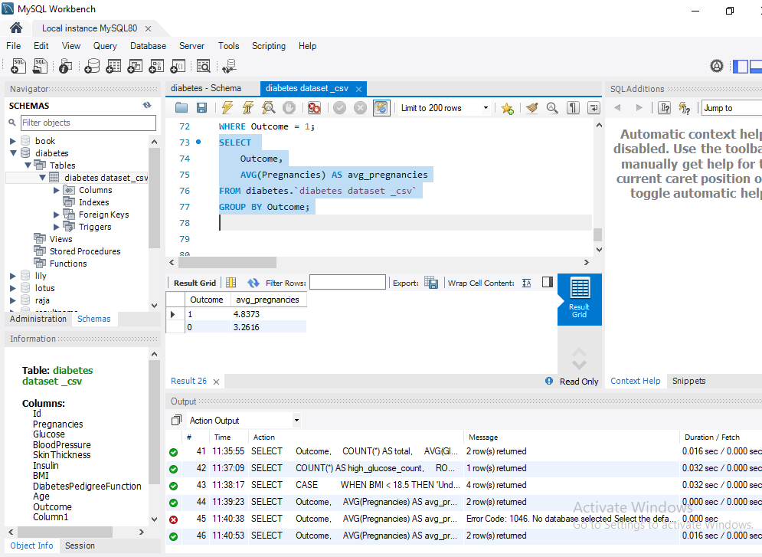
High BMI Patients (BMI > 30):
SELECT
COUNT(*) AS obese_patients,
ROUND(100.0 * COUNT(*) / (SELECT COUNT(*) FROM diabetes.`diabetes dataset _csv`), 2) AS percent_obese
FROM diabetes.`diabetes dataset _csv`
WHERE BMI > 30;
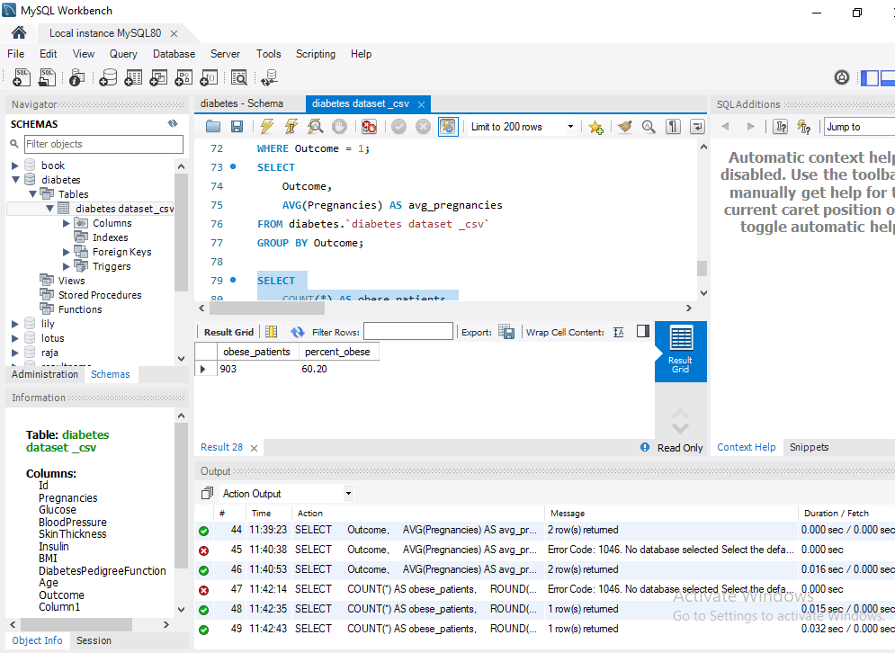
Average Insulin and Glucose for High-Risk Patients:
SELECT
AVG(Glucose) AS avg_glucose,
AVG(Insulin) AS avg_insulin
FROM diabetes_table
WHERE Outcome = 1;
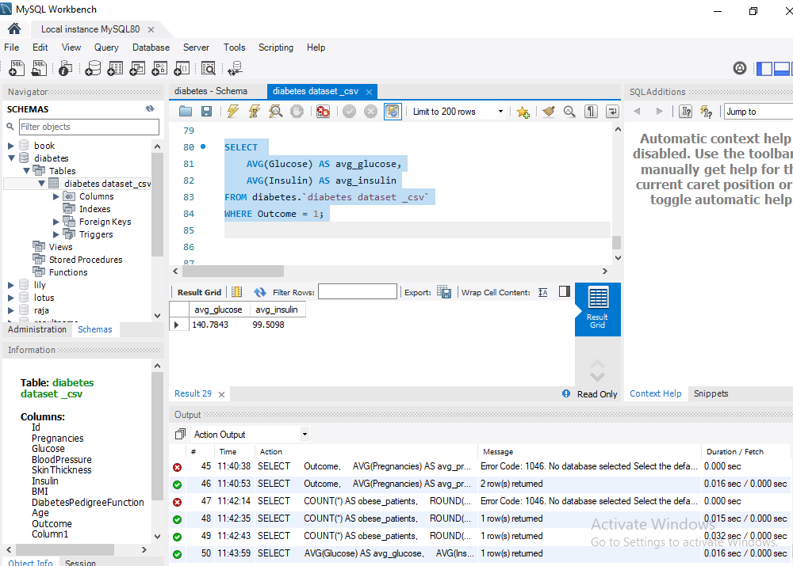
Blood Pressure Category Distribution:
SELECT
CASE
WHEN BloodPressure < 60 THEN 'Low'
WHEN BloodPressure BETWEEN 60 AND 80 THEN 'Normal'
ELSE 'High'
END AS bp_category,
COUNT(*) AS total
FROM diabetes.`diabetes dataset _csv`
GROUP BY bp_category;

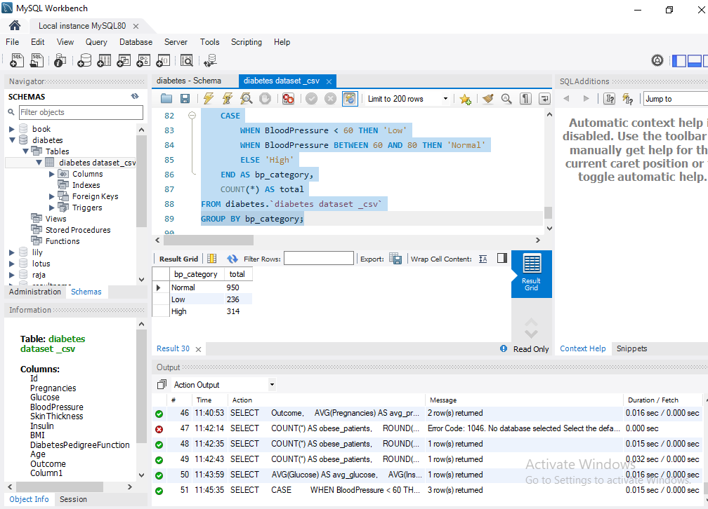
Skin Thickness Average by Age Group:
SELECT
CASE
WHEN Age < 30 THEN 'Under 30'
WHEN Age BETWEEN 30 AND 45 THEN '30–45'
ELSE '45+'
END AS age_group,
AVG(SkinThickness) AS avg_skin_thickness
FROM diabetes.`diabetes dataset _csv`
GROUP BY age_group;
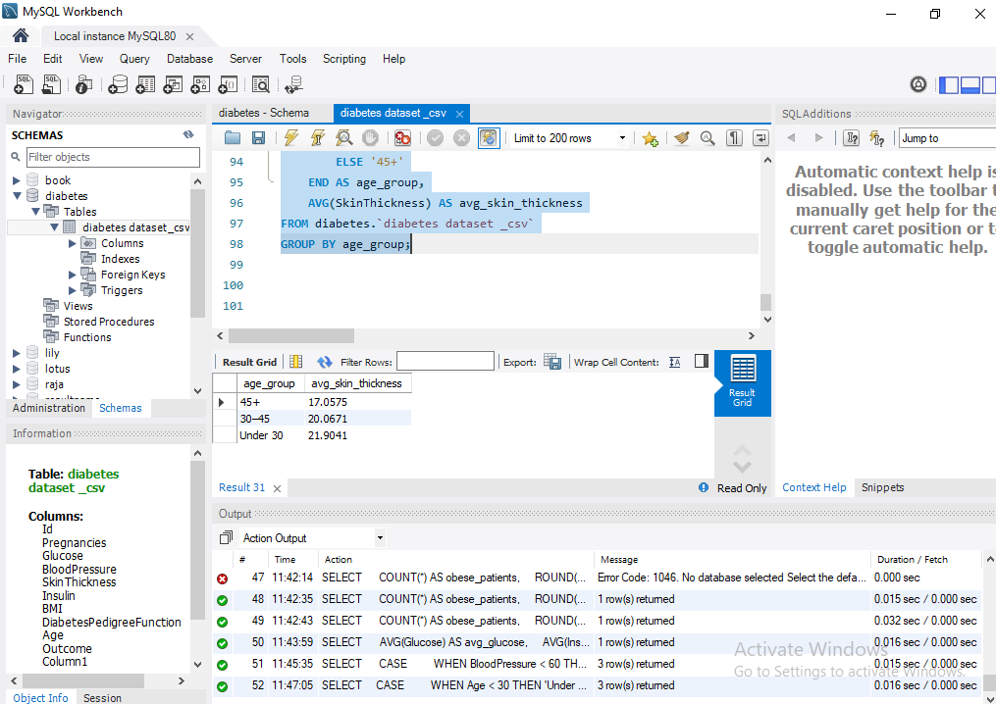
Average Diabetes Pedigree Score by Outcome:
SELECT
Outcome,
AVG(DiabetesPedigreeFunction) AS avg_pedigree_score
FROM diabetes.`diabetes dataset _csv`
GROUP BY Outcome;
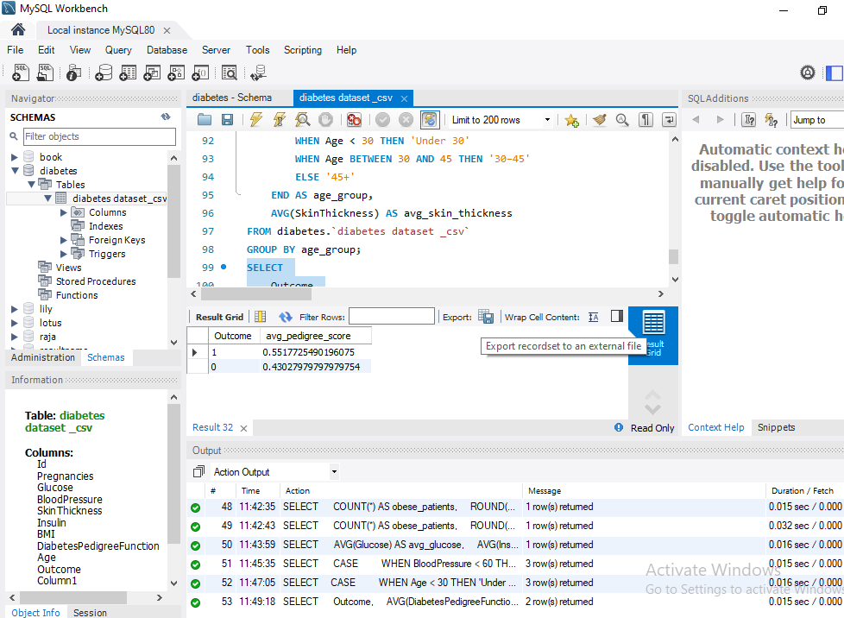
Zero-Insulin Cases:
SELECT
COUNT(*) AS zero_insulin_cases,
ROUND(100.0 * COUNT(*) / (SELECT COUNT(*) FROM diabetes.`diabetes dataset _csv`), 2) AS percent_zero_insulin
FROM diabetes.`diabetes dataset _csv`
WHERE Insulin = 0;
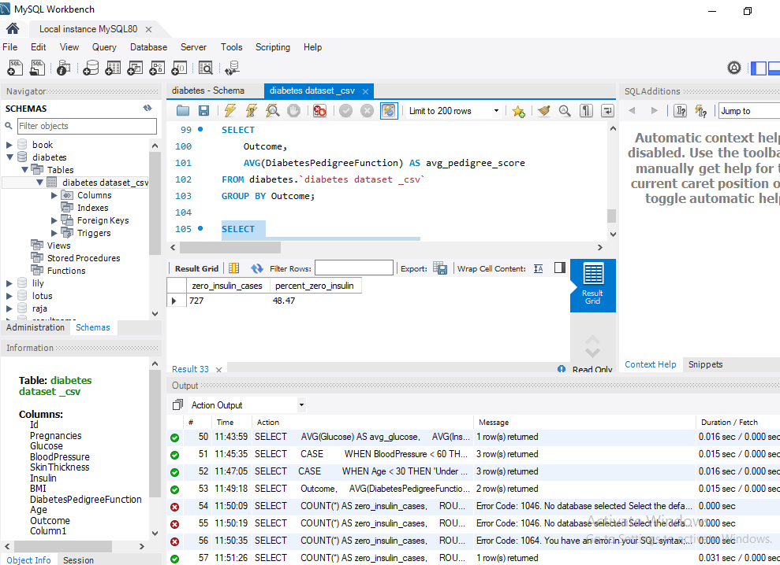
Average Age of Diabetic vs Non-Diabetic:
SELECT
Outcome,
AVG(Age) AS avg_age
FROM diabetes.`diabetes dataset _csv`
GROUP BY Outcome;

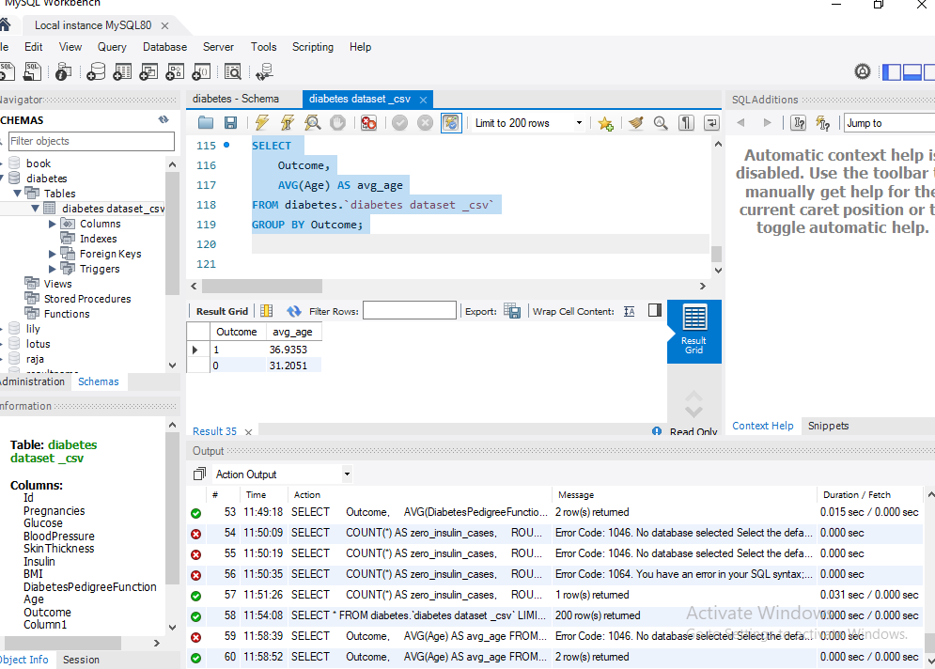
Average Pregnancies (Important for Gestational Risk):
SELECT AVG(Pregnancies) AS avg_pregnancies
FROM diabetes.`diabetes dataset _csv`;
